22Q and the Big Blue
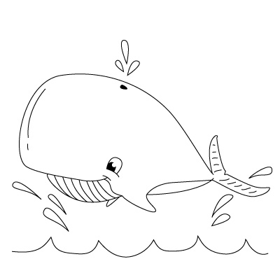
The San Diego celebration of
The International 22Q11.2
Foundation’s 22Q at the Zoo event

Scripps Birch Aquarium
Sunday May 17, 2015 10 am to 4 pm
Come meet other families with 22Q 11.2 DS, enjoy lunch and activities, and interact with marine animals as we participate in the international celebration of people with 22q with over 100 zoos and animal interactions worldwide! $8 per child and $14 per adult (PLUS one free adult for every four children and a free adult for every child that requires a 1:1 aid on their IEP). Contact us for more details!
For reservations and more info: Emily Dolton, San Diego contact parent, insideemilyshead@gmail.com, 858-366-3720
For more info about the international event: www.22q.org

